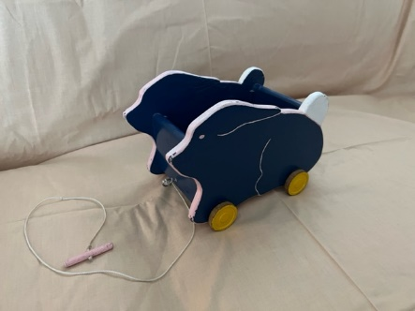Irene Zaugg

CS462-001

September 27, 2023

Module 2: Character Design

# Blue Rabbit White Bear

In a wooden world, a little toy bunny befriends a lost bear. They travel together, helping to solve puzzles and help citizens of the different places they visit. But White Bear knows that his home is somewhere just over the horizon, and Blue Rabbit must figure out how to cope without her dear friend.

## Themes

### Color Pallet

*Blues, earthy colors, wooden textures*

While the textures and flavors of the world suggest hand-carved sculptures (including the two main protagonists), the color scheme mostly keeps with Blue Rabbit’s creation, since she is part of the world. White Bear stands out a little more and has a more battered look.

Overall, the colors and textures suggest a painted, artificial look, even the cities and towns that the characters encounter.

### Mechanics

*Puzzle game, two-character, narrative*

For this version of the game, the player will be able to only control Blue Rabbit, with White Bear being a second character that always follows nearby and should respond automatically to nearby puzzles. For example, a gate might require Blue Rabbit to squeeze through a small opening to push a button, while White Bear simultaneously stands on a heavier button on the other side.

Eventually, White Bear will depart to return to his home, and Blue Rabbit will have to use environmental pieces to solve the puzzles by herself.

The bigger objective of the game will be for the two friends to reach Blue Rabbit’s home, but along the way, alternative paths will be apparent, which lead instead to White Bear’s home.

### Symbols

*Color-coded puzzles, traveling devices*

Puzzles will be presented with nearby color coding, so that Blue Rabbit’s half of the puzzle is somehow tinted or “flagged” with blue, and White Bear’s will be hinted at with white or lighter colors. At the end of the game, the white color will be somewhere nearby, but there will be something else colored blue that indicates Blue Rabbit can use it herself to open the door to her own home (a log or other object that can be pushed onto the button White Bear would normally stand on).

These two colors especially will show up in places where the friends are working closely together, and in the end, there will be small white symbols in Blue Rabbit’s home to remind her of her friend.

Narratively, the color reinforces the idea of the cooperative friendship between the characters, while mechanically, it keys players into the next steps they should take to advance the story.

### Other Themes

This is a story about friendship, loss, and carrying on. The two main characters and all of the adventures they share are based on real art pieces made by my uncle over many years, and so the world should have a sweet, whimsical appeal to it.